1



**IN PARTIAL FULFILLMENT OF THE REQUIREMENTS FOR THE DEGREE OF**

Master In Computer Application

AT

COLLEGE OF IT AND MANAGEMENT EDUCATION

**(A Constituent college of Biju Patanaik University of Technology)**

**Bhubaneswar-751010**

A

**PROJECT REPORT**

**ON**

**SNAKE GAME USING HTML, CSS AND JAVASCRIPT**

**SUBMITTED BY**

**MALAYA KUMAR SWAIN**

**Regd. No-1805107017**

**Under the Guidance of SOURAV KABIRAJ**

**Co-Founder and CPO, YoursOwn: Insticram Systems pvt.Ltd**

1

# DECLARATION

#### I declare that the project report is based on my own work carried out during the course of our study under the supervision of

MR. SOURAV KABIRAJ. I assert the statements made and conclusions drawn are an outcome of my project work.

I further certify that, the work contained in the report is original and has been done by me under the guidance of my supervisor. The work has not been submitted to any other Institution for any other degree/diploma/certificate in this university or any other University of India or abroad to the best of my knowledge and belief.

Name:- MALAYA KUMAR SWAIN

University Regd.No-1805107017

**CERTIFICATE**

This is to certify that the project titled “SNAKE GAME USING HTML,CSS AND JAVASCRIPT” is the bonafide work carried out by MALAYA KUMAR SWAIN a student of MCA, College of IT and Management Education ,a constituent college of Biju Pattnaik University of Technology, Odisha during the academic year 2018- 21 under my guidance,as per guidelines prescribed by the university.

**Signature of the Guide**

**Place: Date:**

# ACKNOWLEDGEMENT

I would like to express my sincere gratitude to my project guide

Mr. SOURAV KABIRAJ for his invaluable guidance, comments and suggestions throughout the course of the project. I would take this opportunity to thank all the teachers of Dept Of MCA, College of It and Management Education for all their supports during the training period. I also thank my roommates for their moral support and encouragement to complete the project in time.

NAME:- MALAYA KUMAR SWAIN

# ABSTRACT

In this project, we propose method for Play Snake game html and JavaScript language. The Snake Game Can play in a html site You have to click on play snake button. In this project, you can play the popular Snake Game just like you played it elsewhere. You have to use the up, down, right or left arrows to move the snake. Foods are provided at the several co-ordinates of the screen for the snake to eat. Every time the snake eats the food, its length will by increased by one element along with the score. It isn't the world's greatest game, but it does give you an idea of what you can achieve with a relatively simple JavaScript program, and perhaps the basis by which to extend the principles and create more interesting games of your own.

# CONTENT

### INTRODUCTION

1. **COMPANY FILE**
2. **THEORITICAL BACKGROUND**

3.1-VISUAL STUDIO CODE

3.2-HTML

3.3-CSS3

3.4-JAVA SCRIPT

### REQUIREMENT

1. **DESIGN**

5.1-HOME PAGE

5.2-ABOUT PAGE

5.3-PLAY SNAKE GAME

### FLOW CHART

1. **TESTING & SCREENSHOTS**

7.1-HOME PAGE

7.2-ABOUT PAGE

7.3-PLAY SNAKE GAMES

7.4-PLAYING

### FOLDER STRUCTURE

8.1-AUDIO

8.2-IMAGE

8.3-JS

### SCORE CODE

9.1-INDEX HTML

9.2-ABOUT HTML

9.3-SNAKE GAME

9.4-SNAKE JS

9.5-STYLE CSS

1. **INTRODUCTION**

The game called "Snake" or "Snake Game" typically involve the player controlling a line or snake, there is no official version of the game, so gameplay varies. In the **game** of **Snake**, the player uses the arrow keys to move a "**snake**" around the board. As the **snake** finds food, it eats the food, and thereby grows larger The **game** ends when the **snake** either moves off the screen or moves into itself. The goal is to make the **snake** as large as possible before that happens ,Nokia has installed the "Snake Game" on many of its phones. The game is also available on several websites, including YouTube, which allows viewers to play the game while a video loads.

## COMPANY PROFILE

#### 1. profile picture.jpgYoursOwn: Insticram Systems Pvt. Ltd.

* 1. Recognised by startup india
  2. Started by NIT Dugrapur
  3. Incubated by CIME(govt. of adisha)
  4. Address :Zone B, Indl. Estate, Plot No.4, Sector A, Mancheswar, Bhubaneswar, Odisha 751010

6. phone **:** 07364915640

## THEORETICAL BACKGROUND

In this **Project**, we're going to create the snake game we used to play on

NOKIA mobile phones. Snake is the common name for a video game concept where the player manoeuvres a line which grows in length, with the line itself being a primary obstacle. The concept originated in the 1976 arcade game Blockade, and the ease of implementing Snake has led to hundreds of versions (some of which have the word snake or worm in the title) for many platforms. After a variant was preloaded on Nokia mobile phones in 1998, there was a resurgence of interest in the snake concept as it found a larger audience. There are over 300 Snake-like games for iOS alone. The player controls a dot, square, or object on a bordered plane. As it moves forward, it leaves a trail behind, resembling a moving snake. In some games, the end of the trail is in a fixed position, so the snake continually gets longer as it moves. In another common scheme, the snake has a specific length, so there is a moving tail a fixed number of units away from the head. The player loses when the snake runs into the screen border, a trail or other obstacle, or itself. And today you're going to create the Snake game using JavaScript and HTML(or HTML5). We won't use any framework to build the game, just Vanilla JavaScript. The basic technology and tools used in this project as follows

### Visual Studio Code

**Visual Studio Code** is a source-code editor developed by Microsoft for Windows, Linux and macOS. It includes support for debugging, embedded Git control and GitHub, syntax highlighting, intelligent code completion, snippets, and code refactoring. It is highly customizable, allowing users to change the theme, keyboard shortcuts, preferences, and install extensions that add additional functionality. The source code is free and open source and released under the permissive MIT License. The compiled binaries are freeware and free for private or commercial use.

### html

Hypertext Markup Language is the standard markup language for documents designed to be displayed in a web browser. It can be assisted by technologies such as Cascading Style Sheets and scripting languages such as JavaScript.

Web browsers receive HTML documents from a web server or from local storage and render the documents into multimedia web pages. HTML describes the structure of a web page semantically and originally included cues for the appearance of the document.

### 3.3 CSS3

**CSS3** is the latest version of the CSS specification. **CSS3** adds several new styling features and improvements to enhance the web presentation capabilities. Note: Our CSS tutorial will help you to learn the fundamentals of the latest **CSS3** language, from the basic to advanced topics step-by-step.

### 3.4. JavaScript

JavaScript, often abbreviated as JS, is a high-level, just-in-time compiled, object- oriented programming language that conforms to the ECMAScript specification. JavaScript has curly-bracket syntax, dynamic typing, prototype-based object- orientation, and first-class functions.

## REQUIREMENTS

#### SOFTWARE REQUIREMENTS:

Operating system:- WINDOWS

Application software:- VISUAL STUDIO CODE Language:- HTML, CSS3 AND JAVASCRIPT HARDWARE REQUIREMENTS

Hard Disk :- 32 GB RAM :- 1 GB

Processor :- Any Pentium version

1. **DESIGN**
   1. **create 3page**

In this project, we use html language to create 3 page that are

1. Home Page
2. About page
3. Play Snake page
   * 1. **Home page**

The Home page is the initial page of the site. it describes the basic information about our page. In the Home page they are 2 buttons that are About and Play Snake. When you click About button it will go to the About page and When you click Play Snake button it will go to the Play snake page. It also describe how to play the snake game.

### About page

The About page is describe about the snake game. In about page there also 2 buttons that are Home page and Play Snake page.When you click Home button it will go back to the Home page and When you click Play Snake button it will go to the Play snake page.

### 5.1.3 Play Snake Page

The Play Snake page is the actual platform where you can play the snake game. There are 2 buttons About and Quit. when you click the About button it will go to the About page and When you click Quit button it will go back to the Home page. To start the game you have to click any of the arrow key.

## FLOW CHART

start



click about button

Enter to about page



click Play snake button

Enter to Play Snake page

About

Quit

Yes

#### click about button

click Quit button

Yes



Enter to Home Page

Play Snake

About



No

press any arrow key to start

## TESTING& SCREENSHOTS

Testing is the major control measure used during software development. Its basic function is to detect errors in the software. During requirement analysis and design, the output is a document that is usually textual and no executable. After the coding phase, computer programs are available that can be executed for testing purpose. This implies that testing not only, has to uncover errors introduced during coding, but also errors introduced during previous phase. Thus the goal of testing is to uncover the requirements, design and coding errors in the programs. So after testing the outputs of my project are as follows:

### Home page

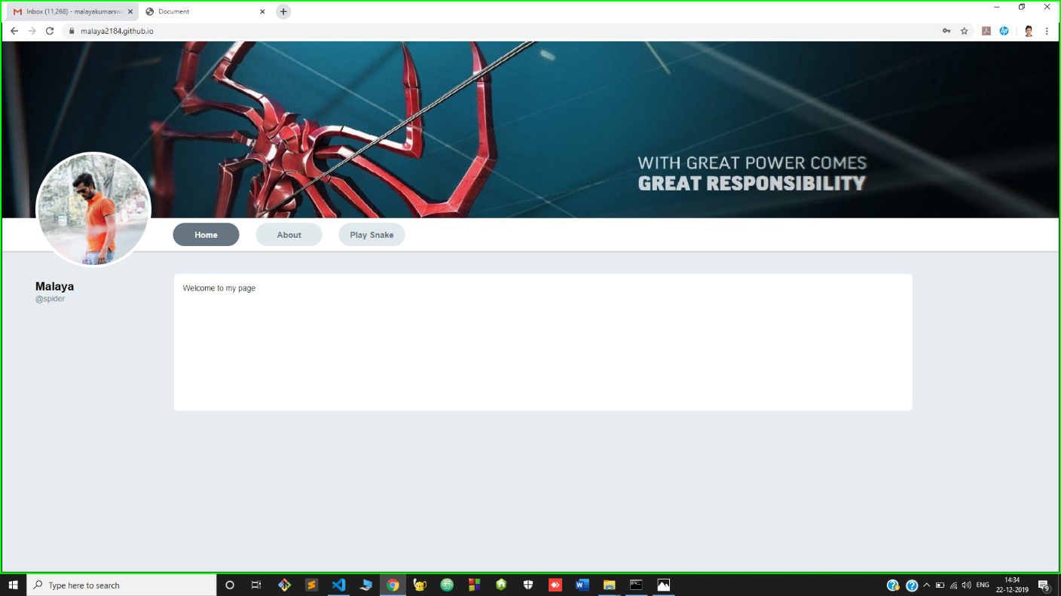

* 1. **About page**

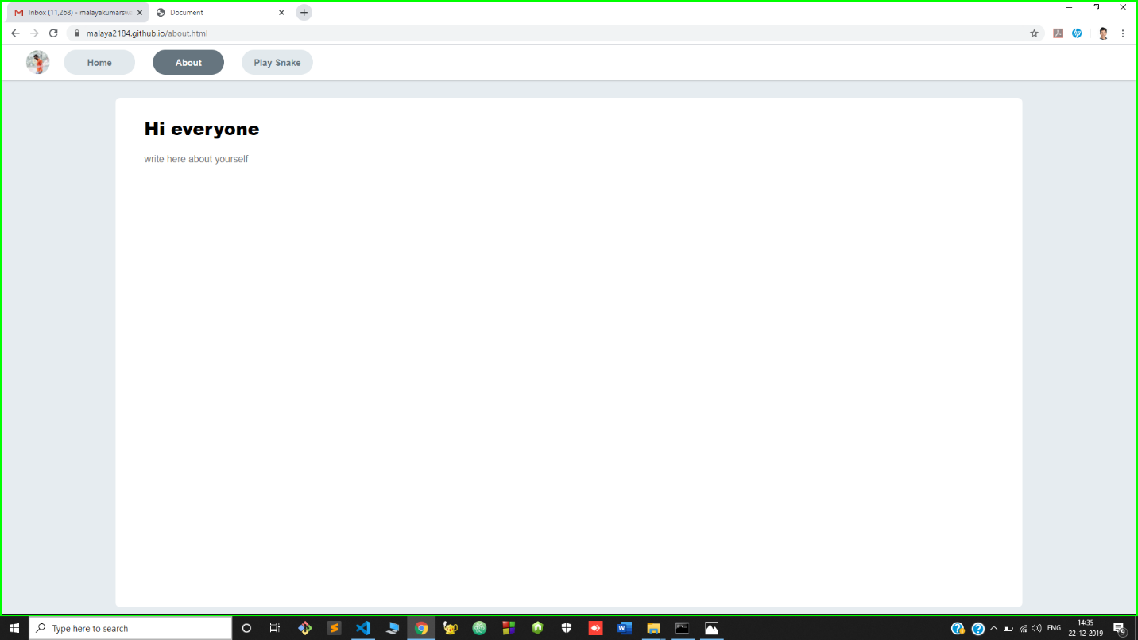

* 1. **Play snake page**

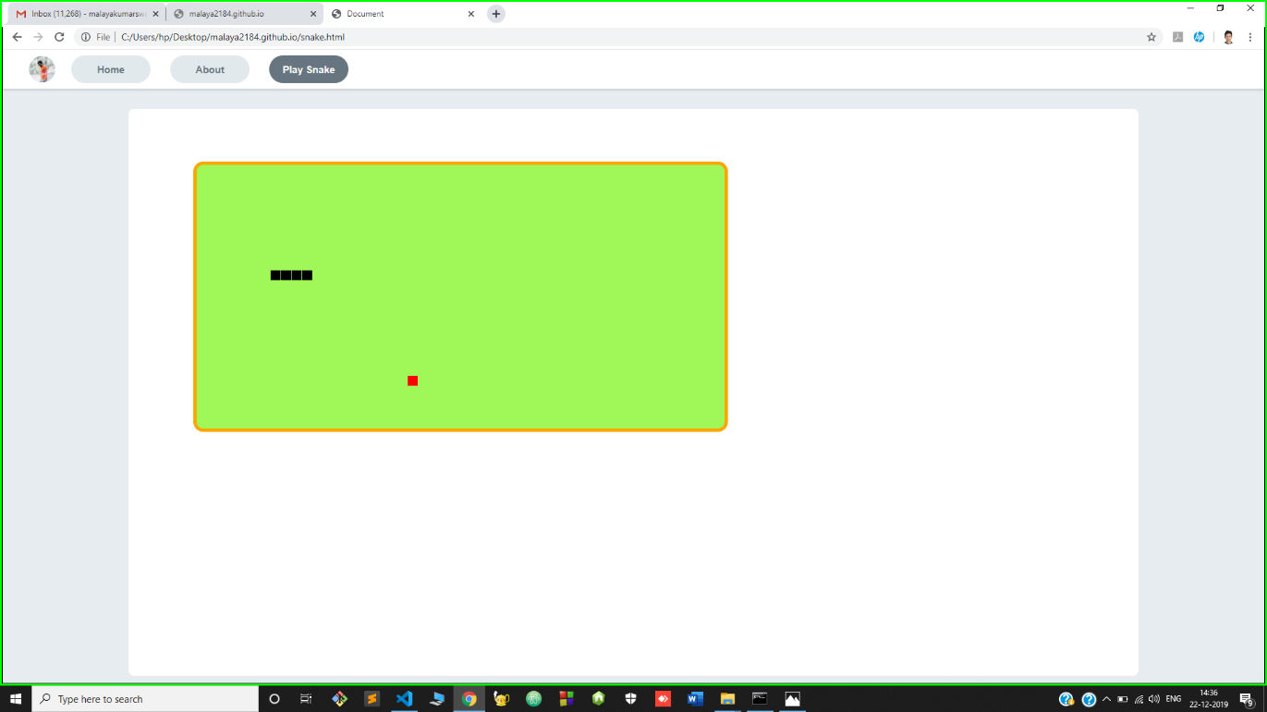

* 1. **Playing**

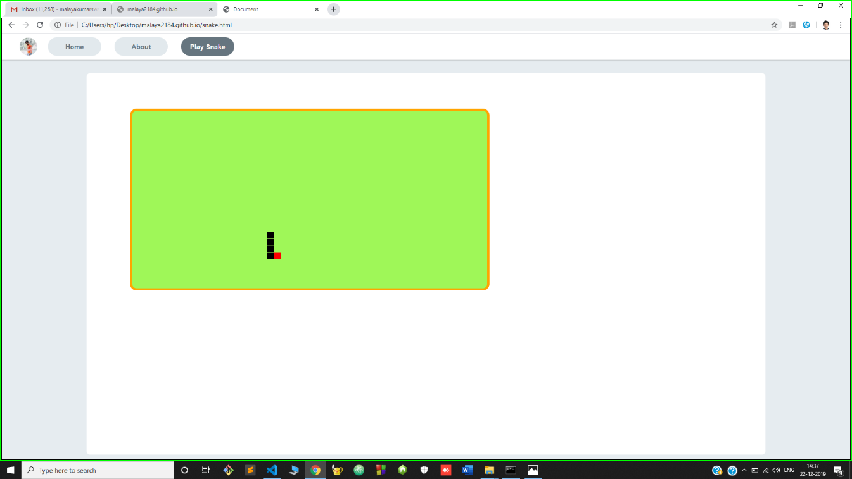

1. **FOLDER STRUCTURE**
   1. **Audio:**

Inside this Folder there The Audio files that are used in the project.

### Image:

Inside this Folder there are The images that are used in the project.

### Js:

Inside this Folder there are the snake.js file.

### Snake.js

Inside this File there are the code in which the snake game code was written. It provide the source code for our snake game.

### Styles:

Inside this Folder there are the styles.css file.

### Styles.css

style.css is a css file format used for formatting content of our page. CSS stands for Cascading Style Sheet and is used by web pages to help keep information in the proper display format. In project this file help to apply styles to our project. **8.5. Index.html**

In this file we write the html code for our home page. It provide the basic structure of the Home page.

### About.html

In this file we write the html code for our About page. It provide the basic structure of the About page.

### Snake.html

In this file we write the html code for our play snake page. It provide the basic structure of the play snake page. In this file it connect with the snake.js file. it provide us the feature to play the snake game.

## SOURCE CODE

* 1. **index.html**

<!DOCTYPE html>

<html lang="en">

<head>

<meta charset="UTF-8" />

<meta name="viewport" content="width=device-width, initial-scale=1.0" />

<meta http-equiv="X-UA-Compatible" content="ie=edge" />

<title>Document</title>

<link rel="stylesheet" type="text/css" href="./styles/style.css" />

</head>

<body>

<div class="background_image"></div>

<div id="avatar_container">

<img id="avatar" src="./images/prof.jpg" alt="spider" obj />

</div>

<div class="nav_container">

<div class="nav_link_container">

<a class="nav_link" href="./index.html">Home</a>

</div>

<div class="nav_link_container">

<a class="nav_link" href="./about.html">About</a>

</div>

<div class="nav_link_container">

<a class="nav_link" href="./snake.html">Play Snake</a>

</div>

</div>

<div class="home_body_container">

<div class="left_pane">

<div class="name">MALAYA</div>

<div class="sub_text">@SPIDER</div>

</div>

<div class="right_pane"> Welcome to my page folks!<br />

Lets dive in together for having a beautiful experience...

</div>

</div>

</body>

</html>

## about.html

<!DOCTYPE html>

<html lang="en">

<head>

<meta charset="UTF-8" />

<meta name="viewport" content="width=device-width, initial-scale=1.0" />

<meta http-equiv="X-UA-Compatible" content="ie=edge" />

<title>Document</title>

<link rel="stylesheet" type="text/css" href="./styles/style.css" />

</head>

<body>

<div class="nav_container nav_container_about">

<div id="avatar_container_about">

<img id="avatar_about" src="./images/prof.jpg"alt="spider"obj/>

</div>

<div class="nav_link_container">

<a class="nav_link" href="./index.html">Home</a> </div>

<div class="nav_link_container">

<a class="nav_link nav_link_selected" href="./about.html">About</a>

</div>

<div class="nav_link_container">

<a class="nav_link" href="./snake.html">Play Snake</a></div></div>

<div class="about_body">

<div class="about_pane">

<div class="about_label_text">Hi everyone</div>

<div class="about_label_content">

Write about here

</div>

</div>

</div>

</body>

</html>

## snake.html

<!DOCTYPE html>

<html lang="en">

<head>

<meta charset="UTF-8" />

<meta name="viewport" content="width=device-width, initial-scale=1.0" />

<meta http-equiv="X-UA-Compatible" content="ie=edge" />

<title>Document</title>

<link rel="stylesheet" type="text/css" href="./styles/style.css" />

</head>

<body>

<div class="nav_container nav_container_about">

<div id="avatar_container_about">

<img id="avatar_about"src="./images/prof.jpg"alt="Spider"obj/>

</div>

<div class="nav_link_container">

<a class="nav_link" href="./index.html">Home</a>

</div>

<div class="nav_link_container">

<a class="nav_link" href="./about.html">About</a>

</div>

<div class="nav_link_container">

<a class="nav_link nav_link_selected" href="./snake.html">Play Snake</a>

</div>

</div>

<div class="about_body">

<div class="about_pane">

<canvas id="game" width="800" height="400"></canvas>

</div>

</div>

<script src="./js/snake.js"></script>

</body>

</html>

## snake.js

var canvas = document.getElementById("game"); var context = canvas.getContext("2d");

var grid = 16; var count = 0;

var snake = { x: 160,

y: 160,

dx: grid, dy: 0,

cells: [], maxCells: 4

};

var apple = { x: 320,

y: 320

};

function getRandomInt(min, max) {

return Math.floor(Math.random() * (max - min)) + min;

}

function loop() { requestAnimationFrame(loop); if (++count < 4) {

return;

}

count = 0;

context.clearRect(0, 0, canvas.width, canvas.height);

snake.x += snake.dx; snake.y += snake.dy;

if (snake.x < 0) {

snake.x = canvas.width - grid;

} else if (snake.x >= canvas.width) { snake.x = 0;

}

if (snake.y < 0) {

snake.y = canvas.height - grid;

} else if (snake.y >= canvas.height) { snake.y = 0;

}

snake.cells.unshift({ x: snake.x, y: snake.y });

if (snake.cells.length > snake.maxCells) { snake.cells.pop();

}

context.fillStyle = "red";

context.fillRect(apple.x, apple.y, grid - 1, grid - 1);

context.fillStyle = "yellow"; snake.cells.forEach(function(cell, index) { context.fillRect(cell.x, cell.y, grid - 1, grid - 1);

if (cell.x === apple.x && cell.y === apple.y) { snake.maxCells++;

apple.x = getRandomInt(0, 25) * grid; apple.y = getRandomInt(0, 25) * grid;

}

for (var i = index + 1; i < snake.cells.length; i++) {

if (cell.x === snake.cells[i].x && cell.y === snake.cells[i].y) { snake.x = 160;

snake.y = 160; snake.cells = []; snake.maxCells = 4; snake.dx = grid; snake.dy = 0;

apple.x = getRandomInt(0, 25) * grid; apple.y = getRandomInt(0, 25) * grid; alert("GAME OVER");

}

}

});

}

document.addEventListener("keydown", function(e) { if (e.which === 37 && snake.dx === 0) {

snake.dx = -grid; snake.dy = 0;

} else if (e.which === 38 && snake.dy === 0) { snake.dy = -grid;

snake.dx = 0;

} else if (e.which === 39 && snake.dx === 0) { snake.dx = grid;

snake.dy = 0;

} else if (e.which === 40 && snake.dy === 0) { snake.dy = grid;

snake.dx = 0;

}

});

requestAnimationFrame(loop);

## 9.4. styles.css

body {

background: #e6ecf0; padding: 0px; margin: 0px; position: relative;

font-family: Helvetica;

}

.background_image { width: 100%; height: 320px;

background-color: #9e9e9e;

background-image: url("../images/background_image.jpg"); background-size: cover;

background-position: 0px -90px;

}

.nav_container{ width: 1000%; height: 60px; padding-left: 300px;

box-sizing: border-box; display: flex; background-color: #fff; flex-direction: row;

box-shadow: 0 1px 3px 0 rgba(0,0,0,0,25);

}

.nav_link_container{ padding: 9px; margin-right: 10px;

}

.nav_link{ width: 120px; height: 100%; display: flex;

justify-content: center; align-items: center; text-decoration: none; color: #000000;

background-color: #0d7bb3; border-radius: 25px;

font-size: 15px; font-weight: 700;

color: #000000;

}

.nav_link_selected { background-color: #66757f; color: #fafafa;

}

#avatar_container

{

width: 210px; height: 210px;

border-radius: 105px; display: flex;

justify-content: center; align-items: center;

background-color: rgb(233, 231, 243); position: absolute;

top: 125px; left: 60px;

}

#avatar

{

width: 200px; height: 200px; border-radius: 100%; object-fit: cover;

}

.nav_container { width: 100%; height: 60px; padding-left: 300px;

box-sizing: border-box; display: flex;

background-color: rgb(235, 223, 223); flex-direction: row;

box-shadow: 0 1px 3px 0 rgba(19, 18, 18, 0.25);

}

.nav_link_container { padding: 9px; margin-right: 12px;

}

.nav_link { width: 120px; height: 100%; display: flex;

justify-content: center;

align-items: center; text-decoration: none; color: #000000;

background-color: #0d7bb3; border-radius: 25px;

font-size: 15px; font-weight: 700;

color: #000000;

}

.home_body_container { width: 100%;

padding-top: 40px; display: flex;

box-sizing: border-box;

}

.left_pane { width: 310px; height: 80px;

padding-left: 60px; padding-top: 10px;

box-sizing: border-box;

}

.right_pane { width: 70%; height: 250px;

background-color: rgb(241, 233, 233); border: 1px solid #071118;

border-radius: 7px; padding: 16px;

box-sizing: border-box; font-size: 14px;

line-height: 20px; font-weight: normal; color: #212121;

}

.name {

font-size: 21px; font-weight: bold; line-height:28px; margin-right: 2px;

}

.sub_text

{

font-size: 14px;

color: #060708; font-weight: lighter;

letter-spacing: 0.1px;

}

/*

about page

*/

.nav_container_about { padding-left: 60px;

}

#avatar_container_about { width: 60px;

height: 100%;

background-color: rgb(245, 205, 205); display: flex;

align-items: center; margin-right: 15px;

}

#avatar_about

{

width: 50px; height: 50px; border-radius: 50%; object-fit: cover;

}

.about_body

{

display: flex;

justify-content: center;

}

.about_pane{ width: 80vw; height: 45vw; margin-top: 30px;

background-color: #fff; border-radius: 8px; padding: 30px 48px; box-sizing: border-box;

}

.about_label_text{ font-size: 30px; font-weight: 900;

margin-bottom: 20px;

}

.about_label_content{ font-size: 16px; color: #757575;

line-height: 150%;

}

#game

{

border: 5px solid rgb(8, 8, 7);

background-color: rgb(39, 153, 153); margin: 50px;

border-radius: 15px;

}

**you can also view the source code in**

[**https://mala**](https://mala)**ya2184.github.io**

1. **APPENDICES**

[www.google.com](http://www.google.com/) <https://www.w3schools.com/> [https://css3-tricks.com/](https://css-tricks.com/) <https://github.com/> <https://git-scm.com/> <http://developer.mdn.org/>